FUNDRAISER
Support our Dancers this Sunday by purchasing a Beautiful Christmas Ornament
$15.00 each
Sponsorships and Freewill Donations
Accepted & Appreciated
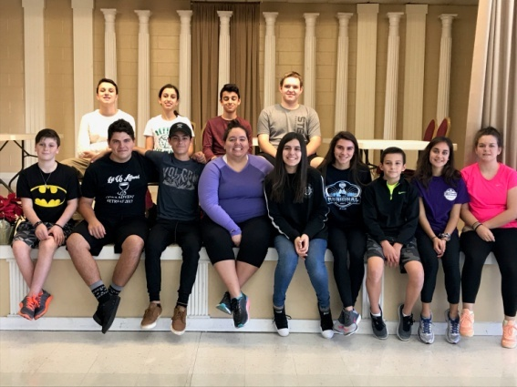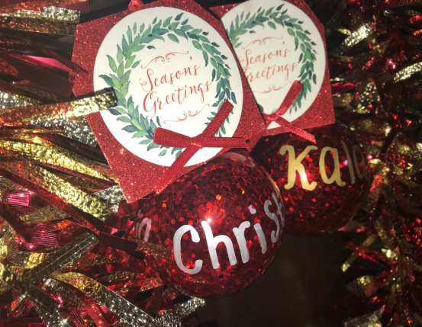
*Funds raised will be used for costumes, dance fees, and other
costs associated with this event
www.hellenicdancefestival.com
January 12-15, 2018 Orlando, FL
Orlando World Center Marriott

